Afon Elai Partnership
WESTWAY SURGERY  1 Wilson Road  Ely  Cardiff  CF5 4LJ |  | LANSDOWNE SURGERY  Sanatorium Road  Canton  Cardiff  CF11 8DG

Dr. John Rhys Jenkins (Male)
BM (Southampton) 1989, DRCOG, 1993, MRCGP 1994
Full time, joined Practice 1995
Diabetes; child health surveillance

Dr. Gillian Ruth James (Female)
BM (Southampton) 1991, DCH 1994, MRCGP 1996
Part time, joined Practice 1999
Obstetrics, contraceptive services, child health surveillance

Dr. Kate Baker (Female)
MBBCH (Cardiff) 1998, Bmedsci 1998, MRCP, 2003, MRCGP 2008, DFSRH 2010.
Part time. Joined Practice 2013.
Minor surgery, obstetrics, contraceptive services

Dr Huw Williams (Male)
MB BS University of Hull 2009
Full time. Joined Practice 2015

Dr Christopher Bryant (Male)
BMBS (Peninsula) 2009, MRCGP 2016
Interface GP, Locality lead
Full time. Joined Practice 2015

Dr Elizabeth Bohemen (Female)
BMedSci BMBS MRCP MRCGP DFFP 1991 (University of Nottingham)
Part time. Joined Practice 2018

Dr Jonathan Crole (Male)
MBBCh (Cardiff) 2010, MRCGP 2016
Full time. Joined Practice 2018

We are a group practice of doctors with a Contract as a Partnership, but not a limited partnership.

Dr Jessica Bryant (Female) Salaried
MBChB (Bristol) 2009 DRCOG 2014 MRCGP 2018
Performs joint injections GPwSI Dementia
Part time. Joined Practice 2018

Dr Lucy Dolman (Female) Salaried
MBBCh (Cardiff) 2003, MRCs, MRCGP, DCH, DFRSH.
Part time. Joined practice in 2021
Family planning, Women’s health (intrauterine device/Implanon fitter), Care of the elderly.

Dr Michak Hegewald (Male) Salaried
MBBS (Newcastle) 2016, PGCert Med Education 2019, MRCGP 2022
Part time. Joined Practice 2022
SURGERY HOURS

Westway and Lansdowne Sites are open Monday to Friday from 8 am – 6.30 pm
In the case of an emergency arising when the surgery is closed, please ring 111. If you have a serious medical emergency dial 999. Cardiff and Vale Healthboard is responsible for contracting the Out of Hours service in Cardiff and Vale.
If you need medical advice telephone NHS Direct on 03454647. www.111.wales.nhs.uk/

Appointments

Please note all calls both incoming and outgoing are recorded for training and monitoring purposes.

We offer a range of appointments with the GP including routine with a GP of choice, telephone and same day for urgent problems. These can be requested via submitting an E consult via our practice website, email reception.w97031@wales.nhs.uk, or over the telephone. We also offer appointments with our practice nurses, healthcare assistant and physician associate. Our reception staff are important members of our team and are trained to direct you to the most appropriate service to meet your needs. In order to do this they need to ask a few screening questions. Staff may also direct you to a local dentist, optometrist as part of the Welsh Eye Care Service, local community pharmacy, MSK physiotherapist or Mental Health Liaison officer.

Missed Appointments

We regularly experience a high number of patients who do not attend for a booked appointment. This results in other patients having to wait longer for an appointment to see the doctor/nurse. It is essential that any patient who cannot attend an appointment, contacts the surgery at least 1 working day before the appointment to cancel and rebook if needed. We monitor patients who fail to cancel appointments, and patients who continually fail to attend appointments may be removed from the practice list. This will result in patients having to find another surgery to register with.

Home Visits

Telephone before 11.00 am where possible. You will be asked for a telephone contact number and details of the problem. A doctor may telephone to assess the call. Please help us to avoid unnecessary home visits by requesting telephone advice in the first instance. Please do not request a house call unless the patient is too ill or infirm to come to the surgery. Do remember that we are very busy and can often see patients more promptly and have better facilities for treatment and examination at the surgery.

How to register

We have an open list and welcome requests for registration from patients living in or moving to the practice area. You can register by completing a form available from our website or from reception.

You will need to complete this and return to the surgery. Where possible please provide us with your NHS number, which can be obtained from your previous GP.

You will be registered as patient of the Practice and will be able to make appointments to see any of our doctors, nurses or other practitioners although sometimes there may be a wait if you wish to have a consultation with a specific clinician. There is always a doctor on duty for urgent on the day appointment requests.

Practice Boundary

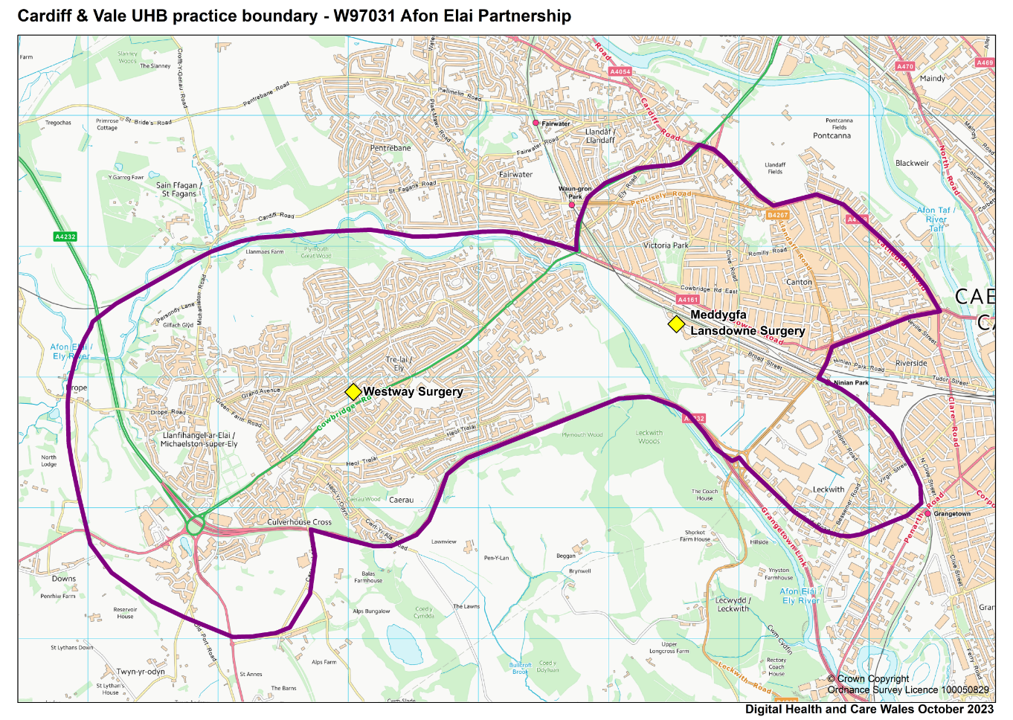

Services Offered

We provide all General Medical servies plus the following additional enhanced services:
- Vacinations
- Childhood immunizations
- Care Homes service
- Oral Anticoagulation with Warfarin
- DOACS
- Diabetes – insulin monitoring
- Hormone Treatment for Adult Transgender Patients
- Substance misuse treatment
- Asylum Seekers And Refugees
- Contraceptive services, COIL fitting & removal, Depo provera contra-ceptive injections and implants.
- Minor surgery
- Medical services for homeless patients
- Learning disabilities medical services

Non-NHS services
The NHS does not pay for some of the services we provide. These include private sick notes, insurance forms, holiday cancellation forms, medical reports, private prescriptions and some vaccination services. Our fees for these services are displayed in the surgery and practice website.

Nursing Team

Advanced Nurse Practitioners
Renu Dona RGN 1994 Independent Prescriber 2015

Practice Nurses
Jenny Tucker Bsc Adult Nursing 2016
Ceri Price Bsc Adult Nursing 2019
Kat Davies Bsc Adult Nursing 2017
Annabelle Rogers Bsc Adult Nursing 2011

Health Care Assistants
Karen Cooper
Russell Allen
Paula Hooper

Pharmacists
Doris Ebubedike Pharm D University of Benin 2007 OSPAP Aston University 2012 Independent Prescriber Cardiff University 2019

Physician Associates
Helen Leger Msc Physician Associate Studies Swansea University 2021
Ray Muniandy Msc Physician Associate Studies Swansea University 2021
Lauren Robbins Msc Physician Associate Studies Swansea University 2020

Paramedics
Paul Crowley Paramedic Practitioner MC Para Mi dip Ip Sp PGCERT 2004

Management Team
Business Manager: Tess Raybould
Operations Manager Westway: Emma Harrhy
Deputy Manager Westway: Hannah Smith
Operations Manager Lansdowne: Amanda Berry
Deputy Operations Manager Lansdowne: Robert Parton

Patient Care Administrators
Our PCA’s work across reception and administration duties and are trained to navigate and direct you to the most appropriate service for your care. This will require them to ask questions about your condition to help the GPs assess your medical need; please be assured they are bound by the same confidentiality agreement as the clinical staff.

Repeat prescriptions
You will need to order prescriptions either via your chemist or our on line tools. Please provide the surgery with your pharmacy choice; prescriptions will then be sent directly to your pharmacy for you to collect your medication.
Prescriptions can be ordered online via our website using our easy order form which can be found in ‘Order Repeat Prescriptions’ under the ‘Services’ tab. Alternatively if you are signed up to My Health On line you can request a prescription via the MHOL service.
You can also order your prescriptions via our e consult service.
If you do not have internet access and are unable to comply with the above you can post your requests to us, enclosing a stamped addressed envelope and we will post your prescription back to you.
Please order your repeat prescription well before you run out of medication and allow two working days before collecting your prescription. All prescriptions received will require 72 hours to process.
Some Pharmacies prefer you to contact them first before attending in order for them to ensure your prescription has been made up for collection; please check with your pharmacist.
We do not take repeat prescription requests over the telephone.

Complaints, concerns and suggestions

In order to help us improve the service we provide, we always welcome feedback from our patients. Whatever your thoughts, please feel free to get in touch with Tess Raybould Business Manager. They can be contacted by letter, by telephone, or email practice.manager.w97031@wales.nhs.uk
Complaints are managed in accordance with the NHS Putting Things Right policy. Patients will be encouraged to complain/comment in writing where possible. All complaints/comments will be treated in the strictest confidence.

CARDIFF AND VALE LOCAL HEALTHBOARD Concerns and complaints

E-mail the team at concerns@wales.nhs.uk or write to us at Chief Executive, Cardiff and Vale University Health Board, Maes y Coed Road, Cardiff CF14 4HH.
Putting things Right – https://gov.wales/nhs-wales-complaints-and-concerns-putting-things-right

Patient rights and responsibilities

We aim to treat our patients courteously at all times and expect our patients to treat our staff in a similarly respectful way. It is your responsibility to keep your appointments, inform us of your past

Violent or abusive behaviour

We take seriously any threatening, abusive or violent behaviour against any of our staff or patients and take a zero tolerance approach to any such behaviour by patients or those accompanying patients. If a patient is violent or abusive, they will be warned to stop their behaviour. If they persist, we may exercise our right to take action to have them removed from our list of patients. Violent episodes will result in referral to the Alternative Treatment Service (for violent patients).

Patient confidentiality

Afon Elai Partnership comply with the Data Protection Act 1998, Human Rights Act 1998, General Data Protection Regulation (EU) 2016/679, Computer Misuse Act 1990 and the Common Law Duty of Confidentiality, all refer to the protection of privacy and confidentiality and must be adhered to at all times.

We respect your right to privacy and keep all your health information confidential and secure. It is important that the NHS keeps accurate and up-to-date records about your health and treatment so that those treating you can give you the best possible care.

This information may be used for management and audit purposes. However, it is usually only available to, and used by, those involved in your care. You have the right to know what information we hold about you. Please see the website for information about how to request a copy of your medical records under a Subject Access Request.

Our privacy notices are available on our website under the patient confidentiality tab

Cardiff & Vale University Health Board Primary, Community and Intermediate Care Team can provide information on all primary medical care services in the area.

Primary Care Services - Cardiff and Vale University Health Board (nhs.wales)

